**Customer Churn Project Report Writing**

**Introduction**

Customer churn, or the rate at which customers stop doing business with a company, is a critical metric for businesses, especially in the telecom industry. High churn rates can significantly impact a company’s revenue and growth potential. By understanding and analyzing customer churn, businesses can develop strategies to retain customers, improve services, and enhance overall customer satisfaction.

**Objective**

The primary objective of this project is to predict and analyze customer churn in the telecom industry using data visualization and analysis tools like Power BI and Tableau, and SQL queries. This will help in identifying at-risk customers, understanding the factors contributing to churn, and developing strategies to mitigate churn.

**Problem Statement**

The telecom industry faces a significant challenge with customer churn, leading to revenue loss and increased customer acquisition costs. To address this, it is essential to identify the factors leading to churn, analyze customer behavior, and implement targeted retention strategies. This project aims to provide a comprehensive solution for understanding and reducing customer churn through data-driven insights.

**Agenda**

**Phase 1: Data Collection and Preparation**

* **Data Collection:** Gather data from various sources including customer demographics, service usage, account information, and churn details.
* **Data Cleaning:** Remove duplicates, handle missing values, and correct inconsistencies.
* **Data Integration:** Combine data from different sources into a unified dataset.

**Phase 2: Data Exploration and Feature Engineering**

* **Exploratory Data Analysis (EDA):** Analyze the data to understand distributions, correlations, and patterns.
* **Feature Engineering:** Create new features that can help in better understanding and predicting churn, such as tenure, monthly charges, total charges, and interaction measures.

**Phase 3: Visualization and Dashboard Creation**

* **Power BI Visualizations:**
  + Identify the total number of customers and the churn rate.
  + Find the average age of churned customers.
  + Discover the most common contract types among churned customers.
  + Analyze the distribution of monthly charges among churned customers.
  + Identify customers with high total charges who have churned.
  + Calculate the average monthly charges for different contract types among churned customers.
  + Identify customers with the highest monthly charges in each contract type.
* **Tableau Visualizations:**
  + Calculate the total charges distribution for churned and non-churned customers.
  + Identify the gender distribution among customers who have churned and are on yearly contracts.
  + Find the customers who have churned and are not using online services, and their average total charges.

**Phase 4: Business Use Case Recommendations**

* **Customer Retention:**
  + Identify at-risk customers and proactively implement retention strategies.
* **Marketing Campaigns:**
  + Tailor marketing efforts towards customers who are more likely to churn.
* **Service Improvement:**
  + Analyze churn patterns to improve service offerings and customer support.
* **Revenue Optimization:**
  + Reduce churn rates to maintain a steady revenue stream.
* **Customer Segmentation:**
  + Segment customers based on churn probability to offer personalized experiences.

**SQL-Based Analysis**

* **Identify Contract Types Prone to Churn:** Create a query to identify which contract types are most associated with churn.
* **Calculate Churn Rate:** Develop a stored procedure to calculate the churn rate.
* **Identify High-Value Customers at Risk of Churning:** Develop a stored procedure to identify high-value customers who are at risk of churning.

**Detailed Dashboard Explanations**

**Power BI Dashboard**

* **Sum of Total Revenue:** Total revenue generated.
* **Sum of Total Charges:** Total charges incurred by customers.
* **Total Customers:** Total number of customers.
* **ARPU (Average Revenue Per User):** Revenue per user segmented by gender.
* **Avg Monthly Charges and Churned Customers by Contract Type:** Average monthly charges and the number of churned customers segmented by contract type.
* **Total Customers by Customer Status:** Number of customers segmented by their status (Stayed, Churned, Joined).
* **Sum of Monthly Charges by Monthly Charge Bins and Customer Status:** Monthly charges distribution for churned customers.
* **Churned Customers by Contract Type:** Number of churned customers segmented by contract type.
* **Total Churned Customers by Gender:** Distribution of churned customers segmented by gender.

**Tableau Dashboard**

* **Churned Customers - No Internet Service and Their Avg Total Charges:** Average total charges for churned customers who do not use internet services.
* **Gender Distribution - Churned Customers on Yearly Contracts:** Gender distribution of churned customers on yearly contracts.
* **Total Charges Distribution for Churned and Non-Churned Customers:** Comparison of total charges between churned and non-churned customers.

By following this agenda, the project aims to provide comprehensive insights into customer churn, enabling the telecom company to develop effective retention strategies and improve overall business performance.

**Phase 1: Data Preparation and Initial Analysis**

**Step 1: Data Acquisition and Preprocessing**

**1.1 Data Download and Understanding**

* **Data Source**: I started by downloading the initial dataset named customer_churn (1).xlsx. This dataset includes various attributes about customers, such as their demographic details, the services they use, and information about churn (whether they have left the service).

**1.2 Conversion to Multiple Sheets**

* **CSV to Excel:** To better organize and analyze the data, I converted the single CSV file into an Excel file with four separate sheets. This helps in managing the data more effectively.
* **Sheets Created:**
  + CustomerDemographics: This sheet contains demographic information about the customers.
  + AccountInformation: This sheet holds details about customer accounts.
  + ServiceInformation: This sheet includes information about the services used by the customers.
  + ChurnInformation: This sheet contains details about customer churn, such as reasons for leaving.

**1.3 Folder and File Organization**

* **CSV Folder:** For better organization, I created a folder named CSV and uploaded the original CSV file into it. This ensures I have a backup and can easily reference the original data.

**Step 2: Data Loading into MySQL**

**2.1 Schema and Table Creation**

* **Creating the Schema**: I set up a schema named customer_churn in MySQL to logically group the tables.

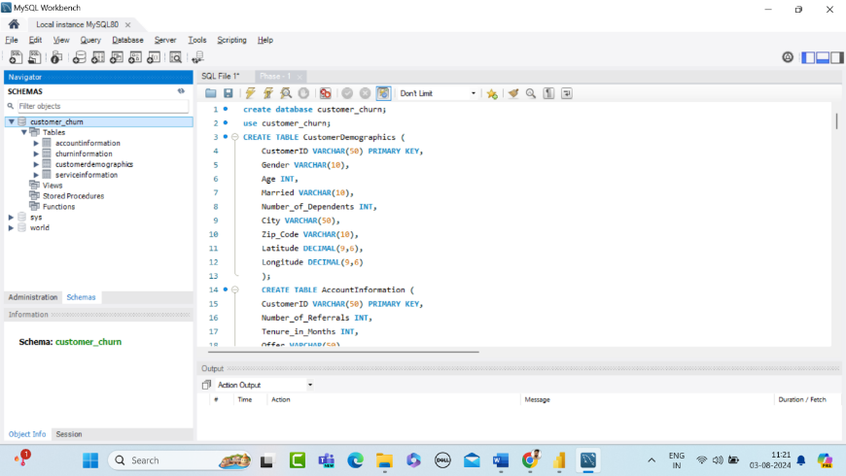

* **Creating the Tables:** I created four tables within this schema to match the Excel sheets:
  + CustomerDemographics
  + AccountInformation
  + ServiceInformation
  + ChurnInformation

These tables were created using SQL queries to define their structure accurately.

**2.2 Data Import**

* **Importing Data**: I imported the data from the Excel sheets into the corresponding MySQL tables using the data import table wizard.
* **Handling Errors:** During the import, I addressed issues like handling blank values to ensure all data was correctly loaded. After importing, I cross-checked the data with queries to verify its accuracy.

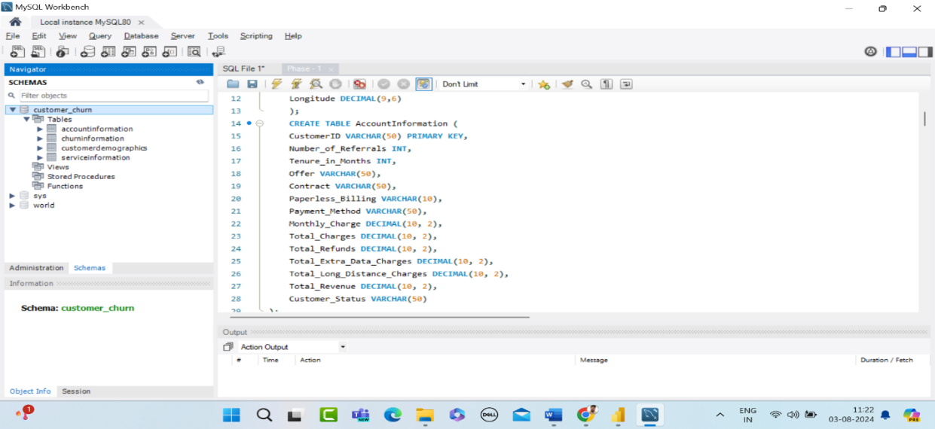

**Step 3: Data Cleaning and Normalization**

**3.1 Handling Missing Values**

* **Identifying Missing Values**: I identified any missing values in the dataset using SQL queries.
* **Filling Missing Values**: To handle these missing values, I filled them using appropriate methods,

**Here’s an example of how I did it:**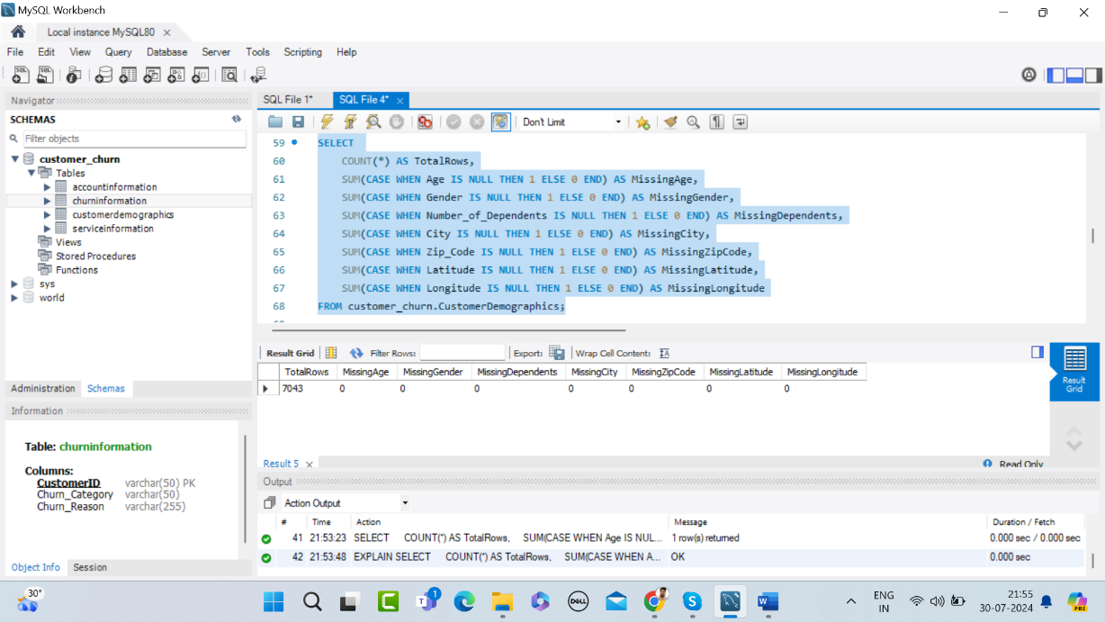

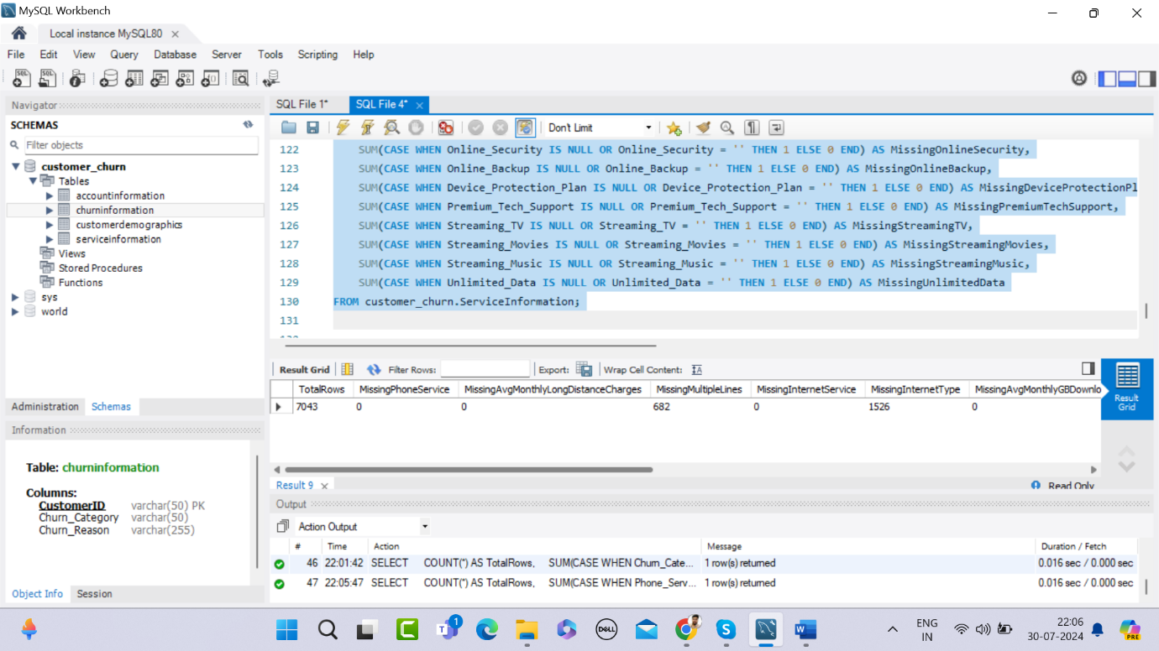

Found Missing Values in Service Information Table

**Filling Missing Values and Verified**

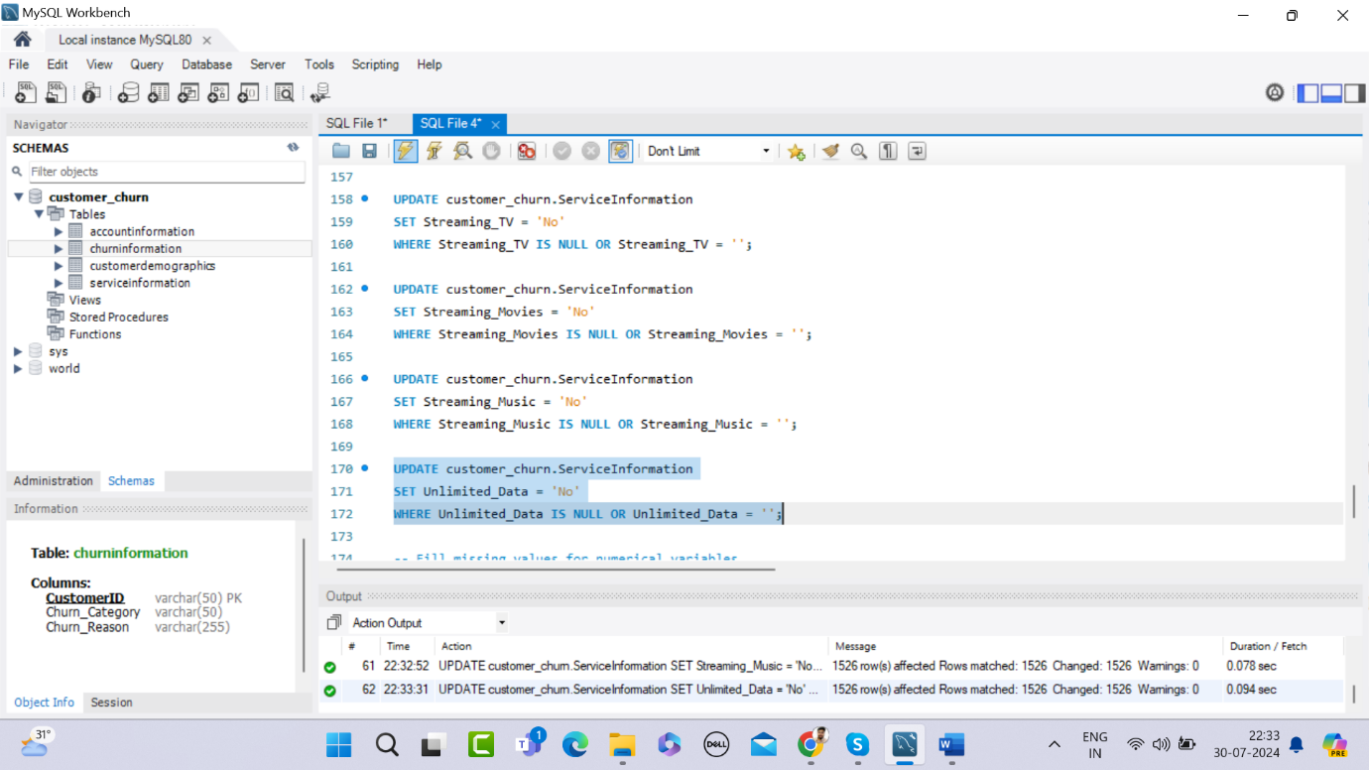

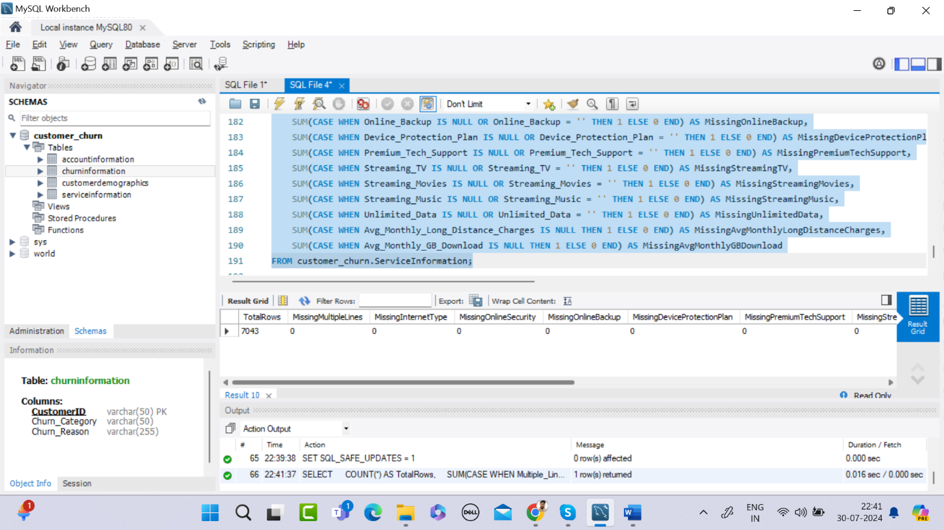

**3.2 Normalization**

* **Normalization Process:** Normalized numerical features to bring them to a comparable scale.
  + Added new columns for Monthly Charge.
  + Calculated min and max monthly charge values using SQL.
  + Drop temp table

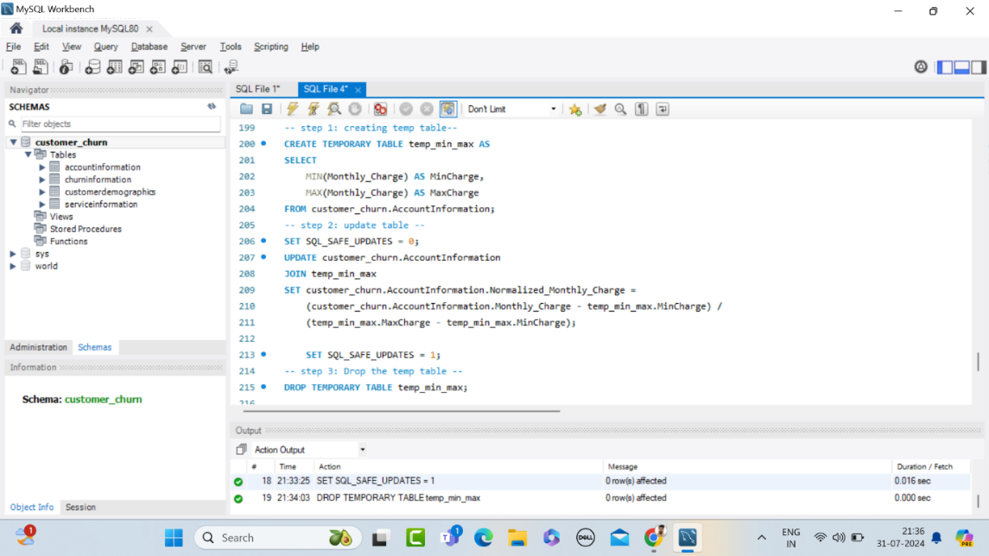

**Step 4: Exploratory Data Analysis (EDA) in Power BI**

**4.1 Data Upload and Relationship Definition**

* **Uploading Data:** I uploaded the Excel file to Power BI for visualization and analysis.
* **Defining Relationships:** I defined relationships between the tables based on the Customer ID field to ensure the data could be analyzed as a connected dataset.

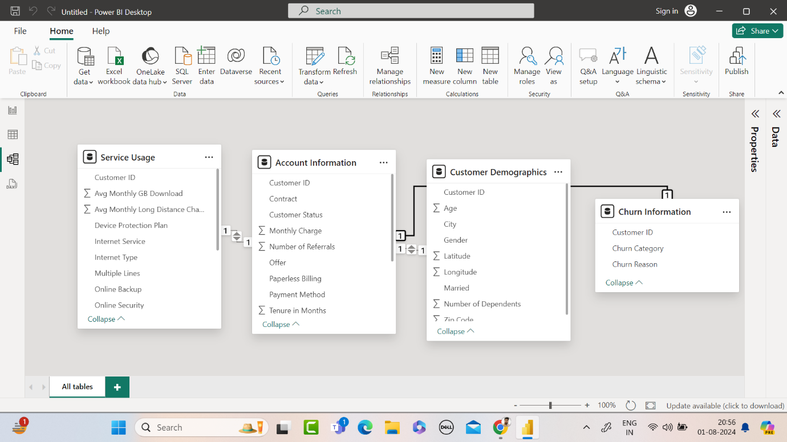

**4.2 Summary Statistics**

* **Calculating Measures:** I measured the following statistics using DAX in Power BI:
  + Mean
  + Median
  + Minimum (Min)
  + Maximum (Max)
  + First Quartile (Q1)
  + Third Quartile (Q3)

**4.3 Correlation Analysis**

* **Correlation Matrix:** I calculated the correlation values between numerical variables to identify relationships and dependencies**.**

**4.4 Visualization**

* **Creating Visuals:**
  + Bar Chart: I created a bar chart to visualize the summary statistics.
  + Correlation Heatmap: I used a heatmap to visualize the correlation matrix, making it easier to spot strong and weak correlations.

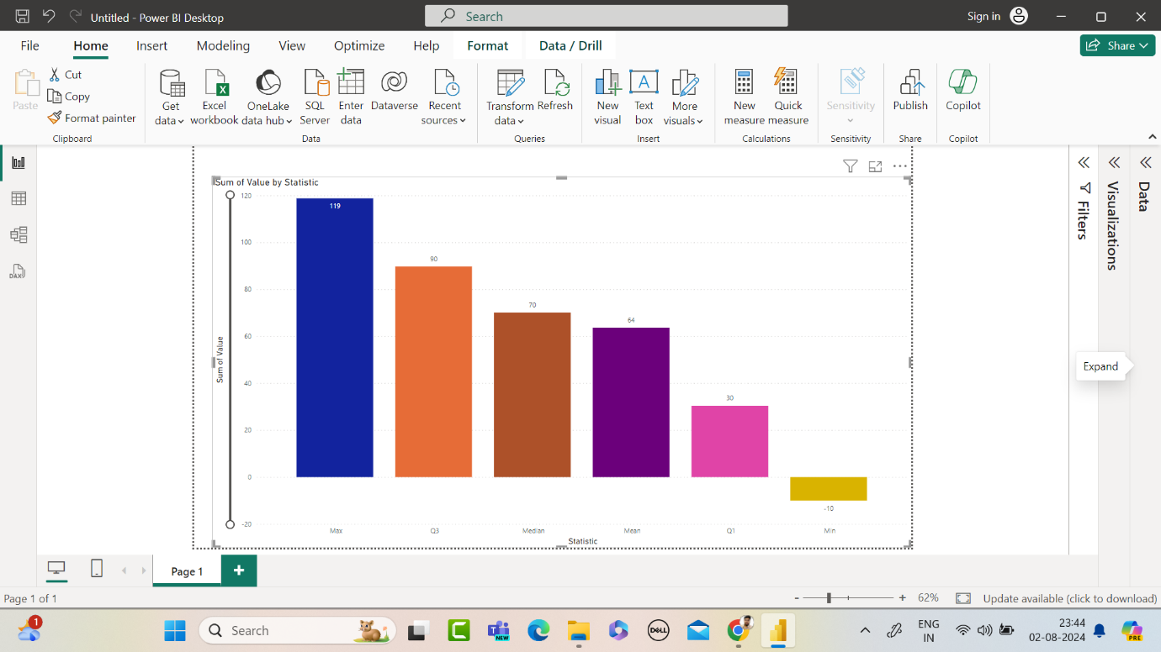

**In Power BI:**

* + Bar Chart Customization: I customized the bar chart by applying different colors for each statistic to make it more readable.
  + Correlation Visualization: The heatmap provided a clear visual representation of how different variables relate to each other.

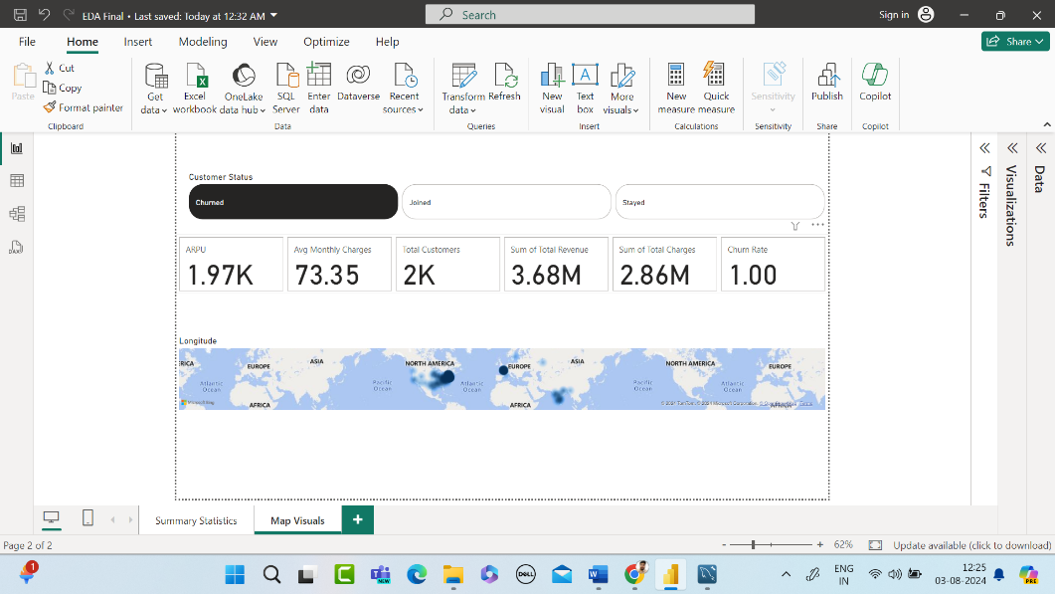

**Conclusion**

In Phase 1, I successfully prepared the data by converting it into a structured format, loaded it into MySQL for further processing, handled missing values and normalization, and performed an initial exploratory data analysis using Power BI. This set a solid foundation for more detailed analysis and model building in subsequent phases**.**

**Phase 2: Feature Engineering and Data Analysis**

In this phase, we will develop specific methods and analyses to address critical business inquiries regarding customer attrition. We will explore the following:

* Identify the total number of customers and the churn rate
* Discover the most common contract types among churned customers
* Create a query to identify the contract types that are most prone to churn
* Calculate the total charges distribution for churned and non-churned customers
* Calculate the average monthly charges for different contract types among churned customers
* Stored Procedure to Calculate Churn Rate
* Stored Procedure to Identify High-Value Customers at Risk of Churning
* Identify the gender distribution among customers who have churned and are on yearly contracts
* Create a view to find the customers with the highest monthly charges in each contract type
* Find the customers who have churned and are not using online services and their average total charges.
* Find the average age of churned customers
* Analyze the distribution of monthly charges among churned customers
* Identify customers with high total charges who have churned

**1. Identify the total number of customers and the churn rate**

**Measures Created in Power BI:**

* **Total Customer Calculation:**

Total Customers = COUNT('Customer Demographics'[Customer ID])

* **Total Churned Customers Calculation:**

TotalChurnedCustomers = CALCULATE(COUNT('Account Information'[Customer ID]),

    'Account Information'[Customer Status] = "Churned"

* **Churn Rate Calculation:**

ChurnRate = DIVIDE([TotalChurnedCustomers], [Total Customers]) * 100

**Explanation:**

* The Total Customers measure counts the total number of rows in the Customer Demographics table.
* The TotalChurnedCustomers measure calculates the number of customers with a status of "Churned" in the Account Information table.
* The Churn Rate measure calculates the percentage of churned customers by dividing the number of churned customers by the total number of customers and multiplying by 100 to get the percentage.

**2. Discover the most common contract types among churned customers**

* **Churned Customers by Contract Type:**

ChurnedCustomersByContractType = CALCULATE(COUNTROWS('Account Information'),

    'Customer Demographics'[Customer Status] = "Churned")

* **Churn Rate Calculation:**

ChurnRate = DIVIDE([TotalChurnedCustomers], [Total Customers]) * 100

**Explanation:**

* The Churned Customers by Contract Type measure calculates the number of churned customers for each contract type.
* The Churn Rate measure calculates the percentage of churned customers by dividing the number of churned customers by the total number of customers and multiplying by 100 to get the percentage.

**3. Create a query to identify the contract types that are most prone to churn**

**SQL Query**

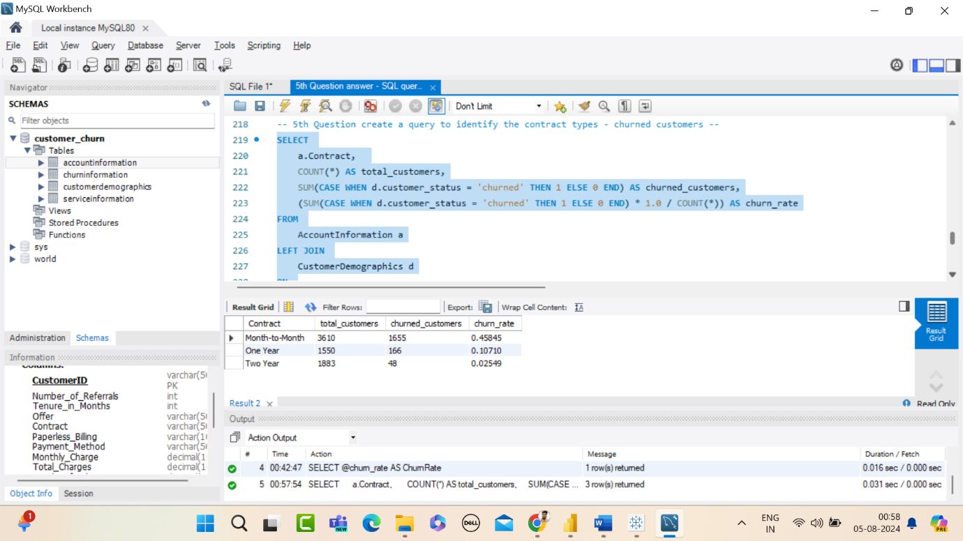

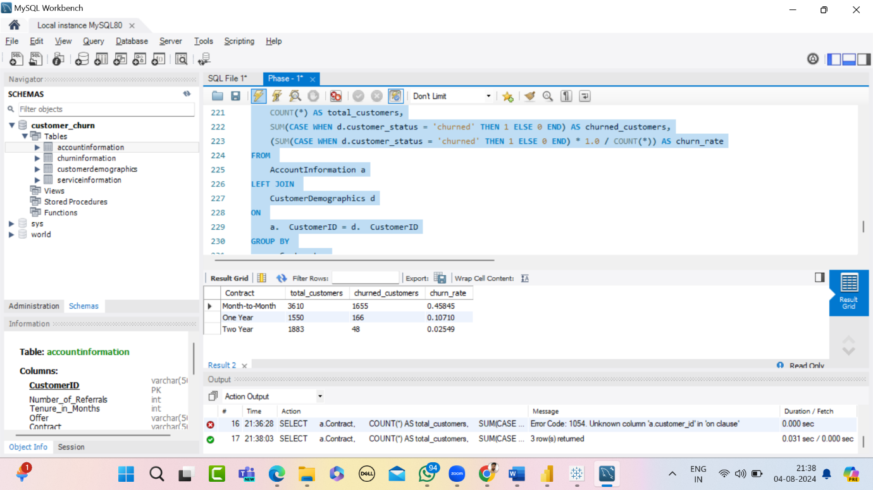

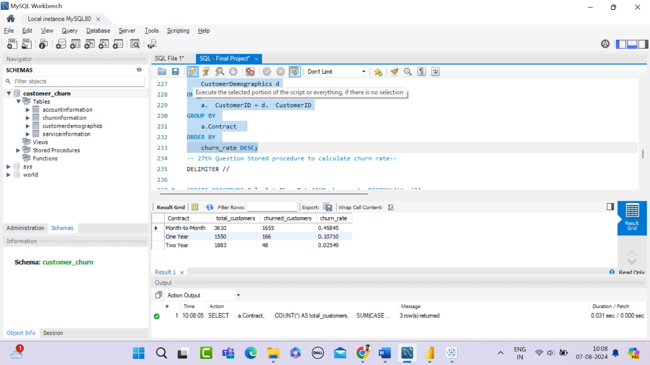

**Explanation:**

* **Selecting the Required Fields:**
  + a.Contract: The type of contract.
  + COUNT(*) AS total_customers: Total number of customers for each contract type.
  + SUM(CASE WHEN d.customer_status = 'churned' THEN 1 ELSE 0 END) AS churned_customers: Total number of churned customers for each contract type.
  + (SUM(CASE WHEN d.customer_status = 'churned' THEN 1 ELSE 0 END) * 1.0 / COUNT(*)) AS churn_rate: Churn rate for each contract type, calculated as the number of churned customers divided by the total number of customers.
* **FROM Clause:**
  + AccountInformation a: Using the AccountInformation table aliased as a.
* **LEFT JOIN Clause:**
  + CustomerDemographics d ON a.CustomerID = d.CustomerID: Joining the AccountInformation table with the CustomerDemographics table on the CustomerID.
* **GROUP BY Clause:**
  + a.Contract: Grouping the results by the contract type.
* **ORDER BY Clause:**
  + churn_rate DESC: Ordering the results by churn rate in descending order.

**Key Points:**

* The LEFT JOIN ensures that all records from AccountInformation are included, even if there are no matching records in CustomerDemographics.
* The CASE statement is used to count churned customers conditionally.
* The 1.0 in the churn rate calculation ensures the division is treated as a floating-point division to get the correct percentage.

By running this query, you will get a list of contract types along with the total number of customers, the number of churned customers, and the churn rate for each contract type, sorted by the churn rate in descending order.

**4. Calculate the total charges distribution for churned and non-churned customers**

**Create a calculated field for Churn Status:**

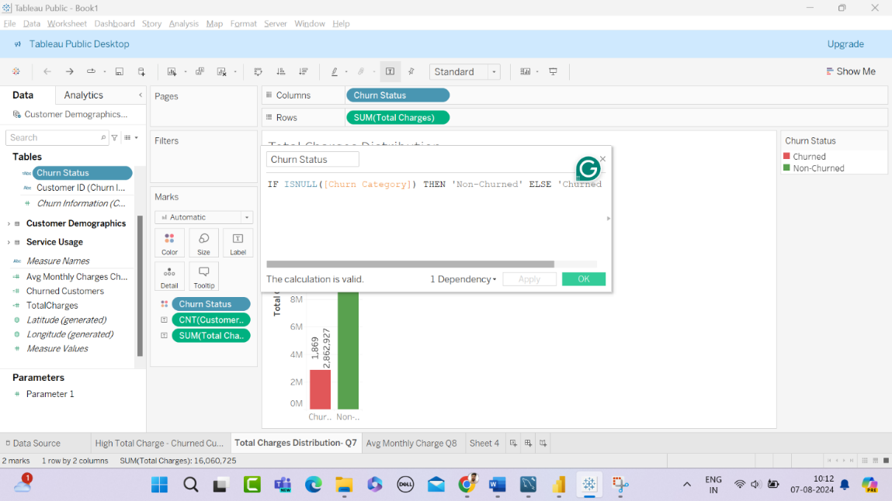

**Explanation:**

* The calculated field Churn Status distinguishes between churned and non-churned customers.

**5. Calculate the average monthly charges for different contract types among churned customers**

**Measures Created in Power BI:**

* **Average Monthly Charges Churned:**

AvgMonthlyChargesChurned = CALCULATE(AVERAGE('Account Information'[Monthly Charge]), 'Account Information'[Customer Status] = "Churned")

* **Churned Customers by Contract Type:**

ChurnedCustomersByContractType = CALCULATE(COUNTROWS('Account Information'),

    'Customer Demographics'[Customer Status] = "Churned")

**Explanation:**

* The Avg Monthly Charges Churned measure calculates the average monthly charges for churned customers.
* The Avg Monthly Charges Churned by Contract Type measure calculates the average monthly charges for churned customers grouped by contract type.

**6. Stored Procedure to Calculate Churn Rate**

**Stored Procedure in MySQL:**

Creating a stored procedure to calculate the churn rate in MySQL involves the following steps:

1. **Define the stored procedure**: This includes setting up the parameters and the structure of the procedure.
2. **Calculate the total number of customers**.
3. **Calculate the number of churned customers**.
4. **Calculate the churn rate**.
5. **Return the result**.

**Explanation:**

1. **DELIMITER //**: Changes the delimiter from ; to // to allow for multi-line procedure definition.
2. **CREATE PROCEDURE CalculateChurnRate**: Defines a new stored procedure named CalculateChurnRate.
3. **OUT churn_rate DECIMAL(10, 2)**: Defines an output parameter churn_rate with a decimal data type.
4. **DECLARE total_customers INT; DECLARE churned_customers INT;**: Declares two integer variables to store the total number of customers and the number of churned customers.
5. **SELECT COUNT(CustomerID) INTO total_customers FROM CustomerDemographics;**: Calculates the total number of customers and stores the result in total_customers.
6. **SELECT COUNT(CustomerID) INTO churned_customers FROM CustomerDemographics WHERE Customer_Status = 'Churned';**: Calculates the number of churned customers and stores the result in churned_customers.
7. **SET churn_rate = (churned_customers / total_customers) * 100;**: Calculates the churn rate as a percentage.
8. **END**: Ends the procedure definition.
9. **DELIMITER ;**: Resets the delimiter back to ;.

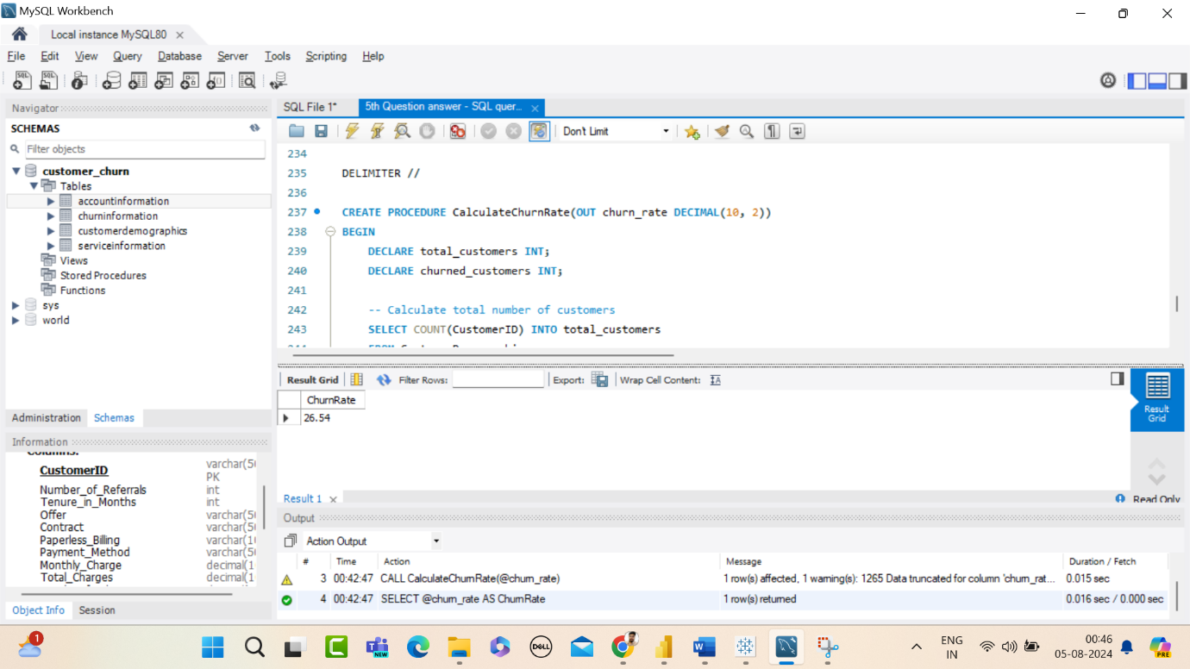

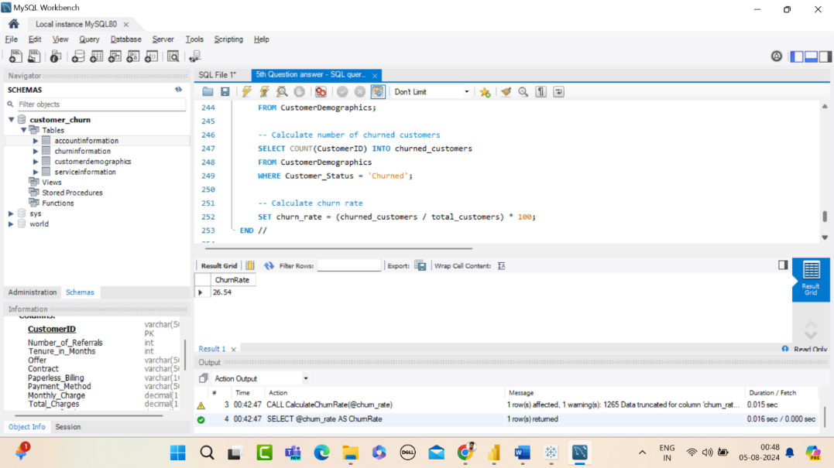

**How to Call the Stored Procedure:**

To call this stored procedure and get the churn rate, you can use the following SQL:

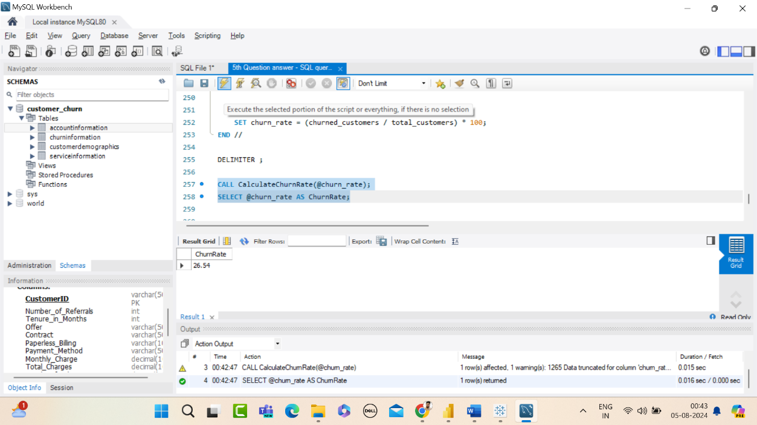

**7. Stored Procedure to Identify High-Value Customers at Risk of Churning**

**Stored Procedure in MySQL:**

The following steps outline the creation and execution of a stored procedure in MySQL to identify high-value customers at risk of churning. The stored procedure filters customers based on a specified threshold for total charges and recognises those who have churned.

**Explanation of the Stored Procedure**

1. **DELIMITER //**:
   * Changes the default statement delimiter (semicolon) to // to allow for the creation of the stored procedure without interference from the semicolon in the procedure body.
2. **DROP PROCEDURE IF EXISTS IdentifyHighValueAtRiskCustomers**:
   * This command ensures that if a procedure with the same name already exists, it is dropped before creating a new one.
3. **CREATE PROCEDURE IdentifyHighValueAtRiskCustomers(IN totalChargeThreshold DECIMAL(10, 2))**:
   * **CREATE PROCEDURE**: Defines a new stored procedure named IdentifyHighValueAtRiskCustomers.
   * **IN totalChargeThreshold DECIMAL(10, 2)**: Declares an input parameter named totalChargeThreshold of type DECIMAL(10, 2) to specify the threshold for total charges.
4. **BEGIN ... END**:
   * Encloses the body of the stored procedure.
5. **SELECT Statement**:
   * **SELECT a.CustomerID, d.Age, d.Gender, a.Total_Charges, a.Monthly_Charge, a.Tenure_in_Months, a.Customer_Status**:
     + Specifies the columns to retrieve from the AccountInformation and CustomerDemographics tables.
   * **FROM AccountInformation a JOIN CustomerDemographics d ON a.CustomerID = d.CustomerID**:
     + Performs an inner join between the AccountInformation (aliased as a) and CustomerDemographics (aliased as d) tables based on the CustomerID column.
   * **WHERE a.Total_Charges > totalChargeThreshold AND a.Customer_Status = 'churned'**:
     + Filters the results to include only customers with total charges greater than the specified threshold and a customer status of 'churned'.
6. **END //**:
   * Ends the body of the stored procedure.
   * The // delimiter marks the end of the procedure definition.
7. **DELIMITER ;**:
   * Resets the statement delimiter back to the default semicolon.
8. **CALL IdentifyHighValueAtRiskCustomers(2000.00);**:
   * Executes the stored procedure with a totalChargeThreshold value of 2000.00, retrieving customers who have total charges above this threshold and have churned.

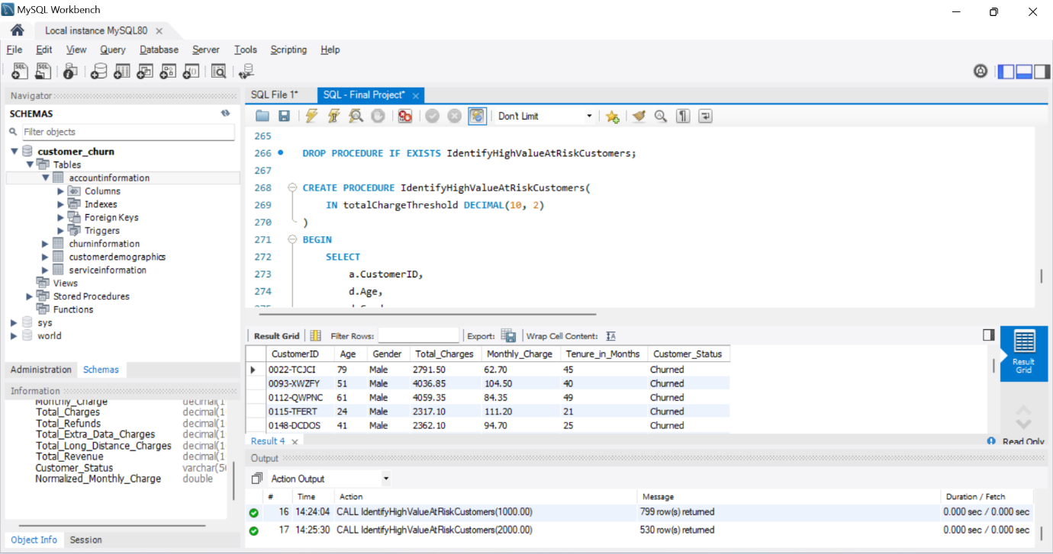

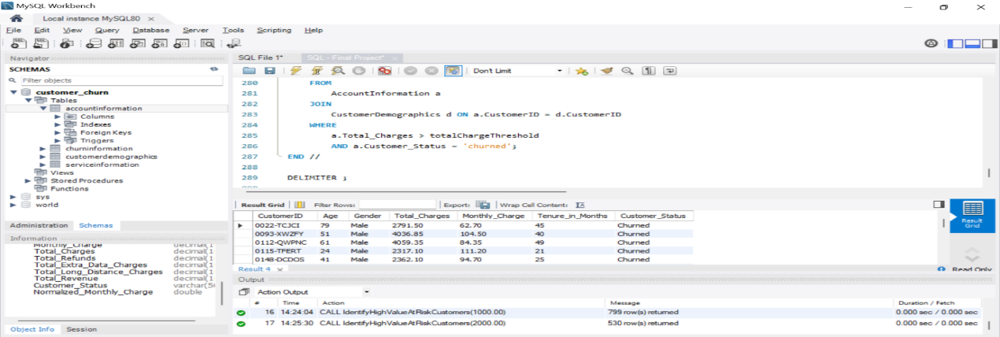

**How to Modify the Threshold Limit**

If you want to change the threshold limit after the stored procedure has been created, you can simply call the stored procedure with a different value for the totalChargeThreshold parameter:

CALL IdentifyHighValueAtRiskCustomers(3000.00);

This call will now filter customers with total charges above 3000.00 and who have churned. You do not need to modify the stored procedure itself; just adjust the parameter value when calling it.

**8. Identify the gender distribution among customers who have churned and are on yearly contracts**

To identify the gender distribution among customers who have churned and are on yearly contracts in Tableau, follow these steps:

Steps and Explanation:

**Filter Churned Customers on Yearly Contracts:**

* **Description:**
  + Drag CustomerStatus to the Filters shelf and select the status that represents churned customers (e.g., "Churned").
  + Drag Contract to the Filters shelf and select the contract type that represents yearly contracts (e.g., "one year" and “two years”).
  + **Description:** Drag COUNT(CustomerID) to Label on the Marks card to display the count of customers directly on the bars.
  + Drag Gender to Color on the Marks card to differentiate genders by color.

**Summary:**

The use of filters, customizations, and labels ensures that the visualization is focused, clear, and informative, aiding in effective data analysis and decision-making.

**9. Create a view to find the customers with the highest monthly charges in each contract type**

For this question, - I used contract type, monthly charge, customer ID for the count, and For more visual appeal used card and slice

**10. Find the customers who have churned and are not using online services, and their average total charges.**

For this question, I used the filter – customer status “churned” and Internet service “No”

Avg total charges of churned customers measure found. For more clarity added gender wise classification in the label.

**11.Find the average age of churned customers**

AvgAgeChurnedCustomers = CALCULATE(AVERAGE('Customer Demographics'[Age]), 'Account Information'[Customer Status] = "Churned")

Explanation: This measure calculates the average age for customers whose status is "Churned".

**12.Analyze the distribution of monthly charges among churned customers**

Monthly Charge field to create bins. – created bin group

**Filter for Churned Customers:**

* Apply a filter to include only churned customers.
* Explanation: Filtering ensures the analysis is specific to churned customers.

**13.Identify customers with high total charges who have churned**

Found Churned Total Charges measure, filter churned customer,

ChurnedTotalCharges = CALCULATE(SUM('Account Information'[Total Charges]), 'Account Information'[Customer Status] = "Churned")

**Conclusion:**

By following these methods, businesses can effectively analyze customer churn data, identify key insights, and develop strategies to improve customer retention.

**Phase 3: Visualization and Dashboard Creation**

In this phase, I created visualizations and dashboards in Power BI and Tableau to provide insights into customer churn.

**Power BI Visualizations**

1. **Identify the Total Number of Customers and the Churn Rate**

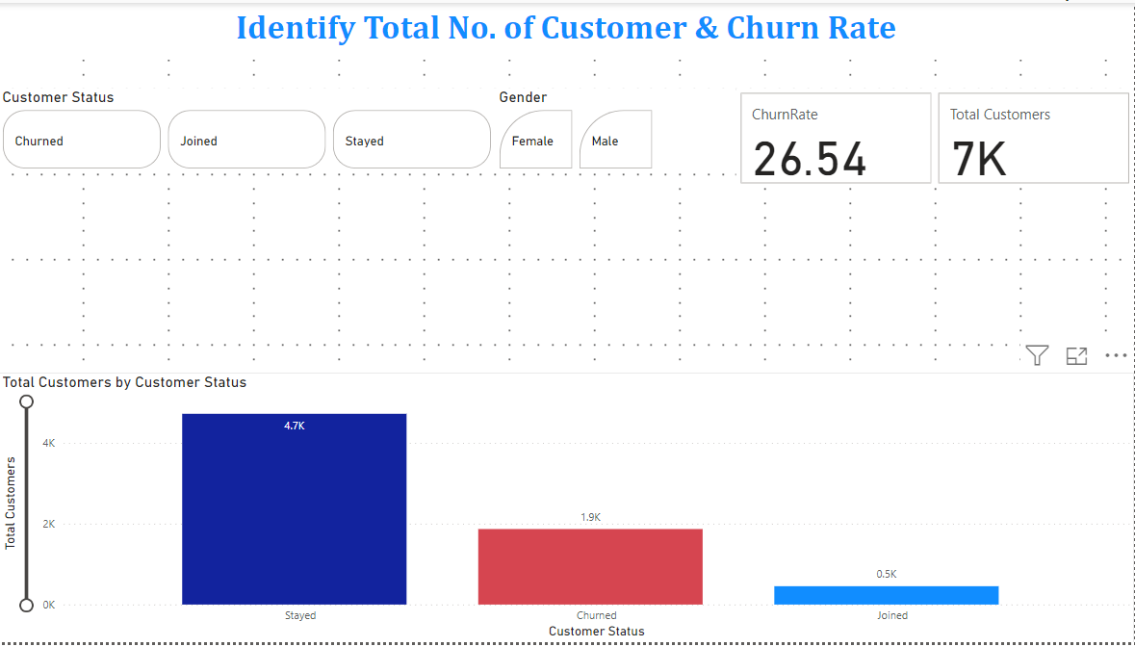

* From this visual, we can understand the total no. of customers, churn rate.
* X-axis Customer status
* Y-axis Total Customers
* Added cards, and slicers for a more appealing visual

1. **Discover the Most Common Contract Types Among Churned Customers**

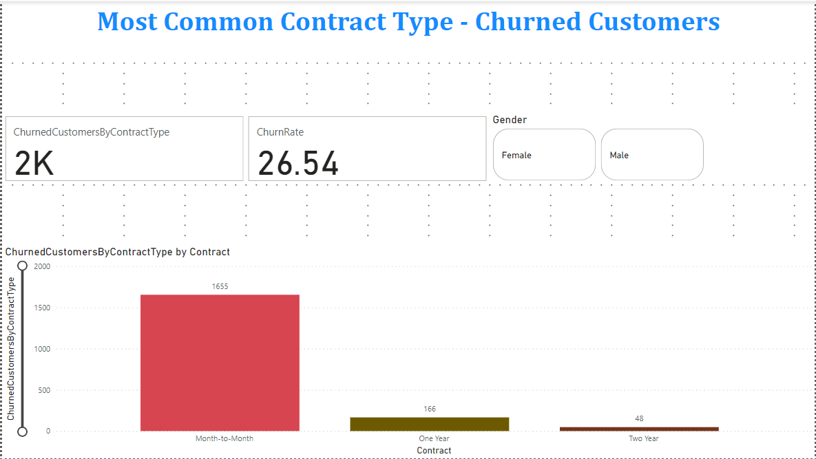

* X-axis Contract
* Y-axis Churned Customers by Contract Type
* For better clarity, added a card visual and a slice visual.

**SQL Visualization:**

**SQL Visualization and Analysis**

In this section, we have addressed three key business questions using SQL. The focus is on identifying contract types prone to churn, calculating the churn rate, and identifying high-value customers at risk of churning.

**3. Create a Query to Identify the Contract Types That Are Most Prone to Churn**



This query provides a list of contract types along with the total number of customers, the number of churned customers, and the churn rate for each contract type, sorted by the churn rate in descending order.

**Tableau Visualizations**

**4.Total Charges Distribution for Churned and Non-Churned Customers**

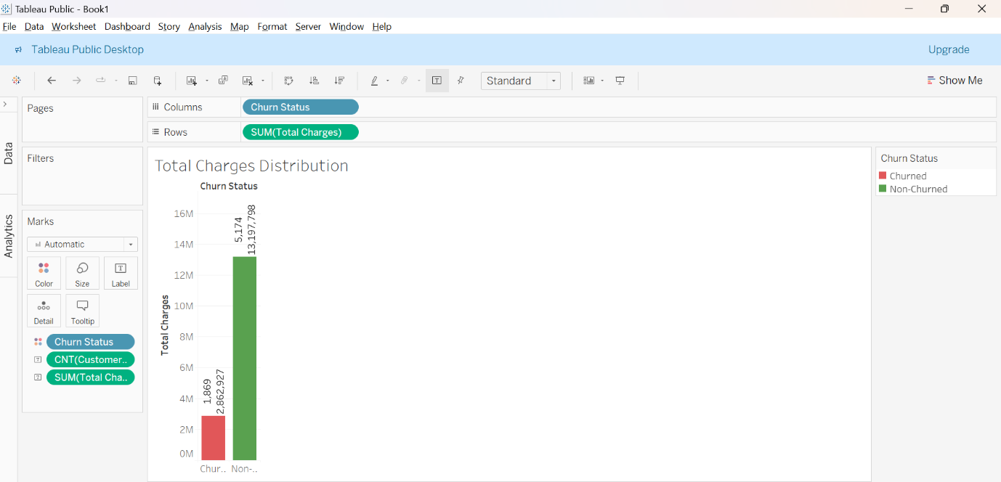

* Created a field to distinguish between churned and non-churned customers.
* From the bar visual, total charges distribution for both churned and non-churned customers.
* X-axis Churn Status
* Y-axis Total Charges

**Power BI Visualization:**

**5. Calculate the Average Monthly Charges for Different Contract Types Among Churned Customers**

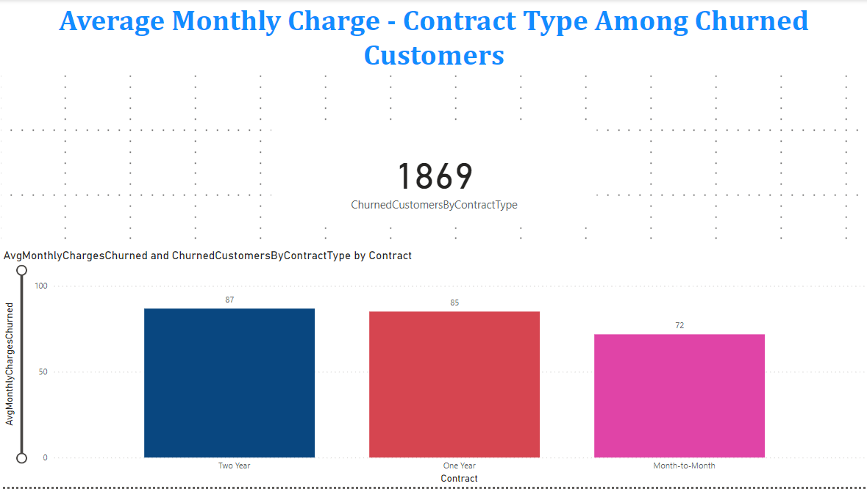

* For this visual avg. monthly charges churned measure created and churned customers by contract type measure used.
* X-axis Contract
* Y-axis Avg. Monthly Charges Churned
* Churned Customer by Contract type used for clear visual.

**SQL Visualization:**

**6. Stored Procedure to Calculate Churn Rate**

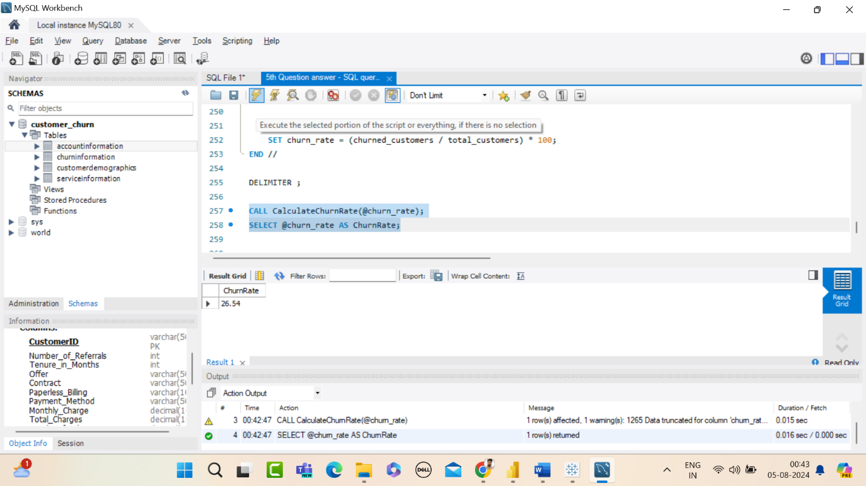

* This stored procedure calculates the churn rate and outputs it as a percentage.

**SQL Visualization:**

**7. Stored Procedure to Identify High-Value Customers at Risk of Churning**

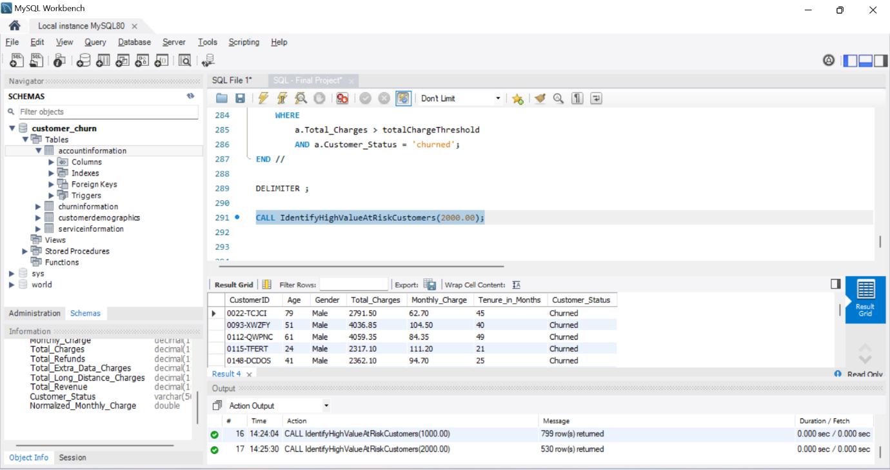

This stored procedure identifies high-value customers who have churned and had total charges above a specified threshold.

**Summary:**

By using these queries and stored procedures, we can gain valuable insights into customer behavior, identify at-risk customers, and develop strategies to reduce churn.

**Tableau Visualization:**

**8. Gender Distribution Among Customers Who Have Churned and Are on Yearly Contracts**

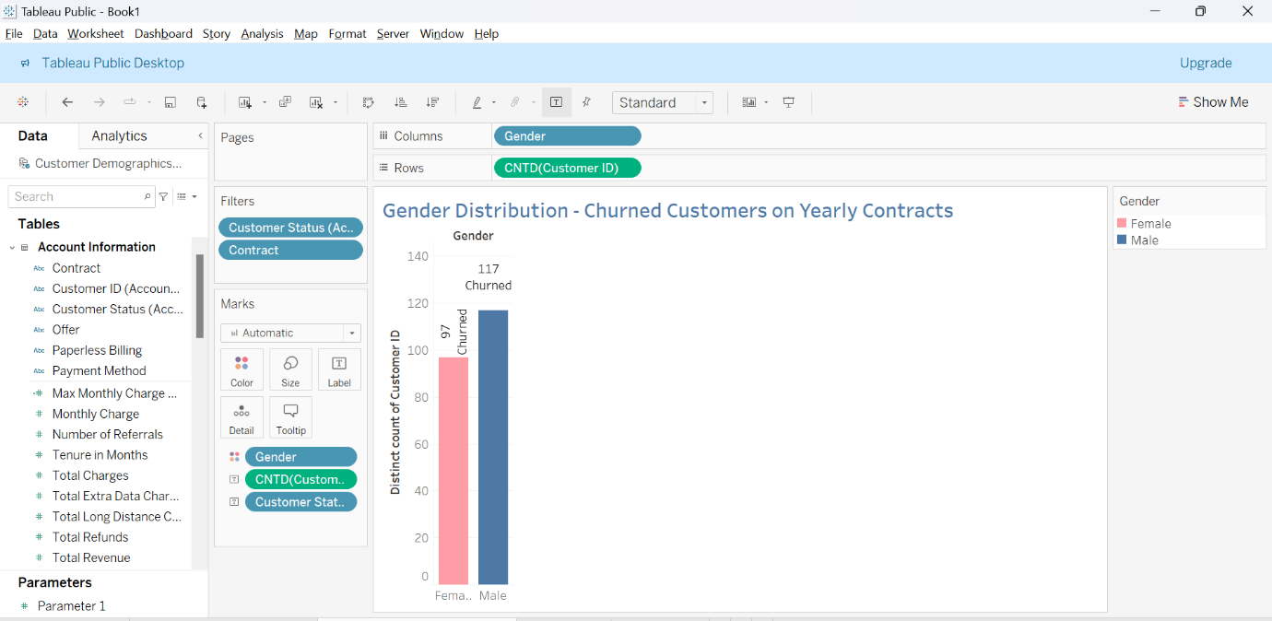

* From this visual, we can understand the gender distribution among churned customers on yearly contracts.
* Selected both 1 year and 2 year contract customers

**Power BI Visualization:**

**9. Customers with the Highest Monthly Charges in Each Contract Type**

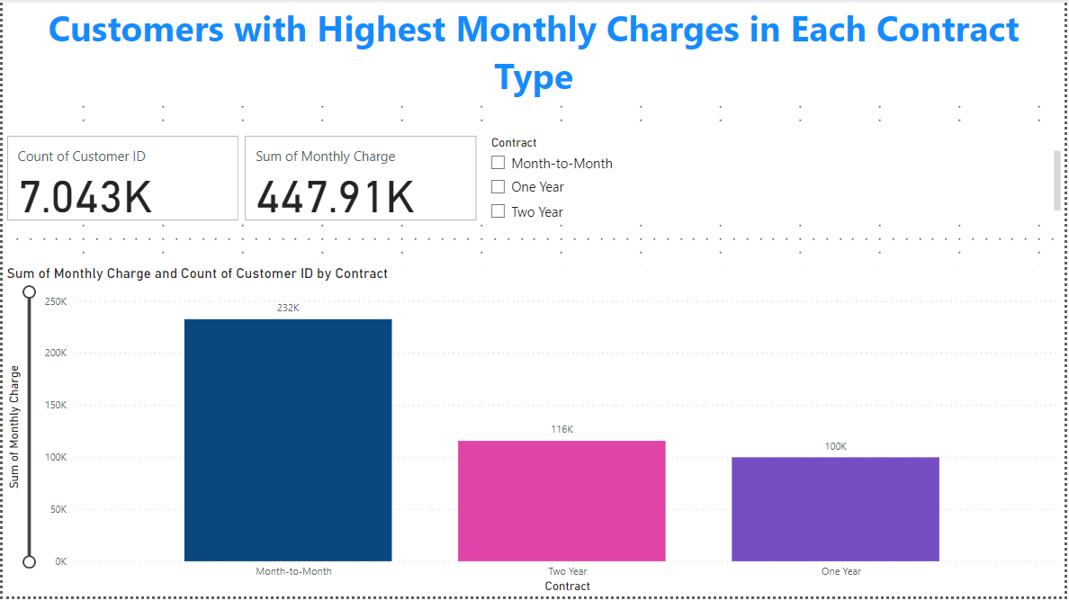

* X-axis Contract
* Y-Monthly Charge
* For more clarity, added a card visual – total customers, monthly charge. Slicer used for contract type.

**Tableau Visualization:**

**10. Customers Who Have Churned and Are Not Using Online Services, and Their Average Total Charges**

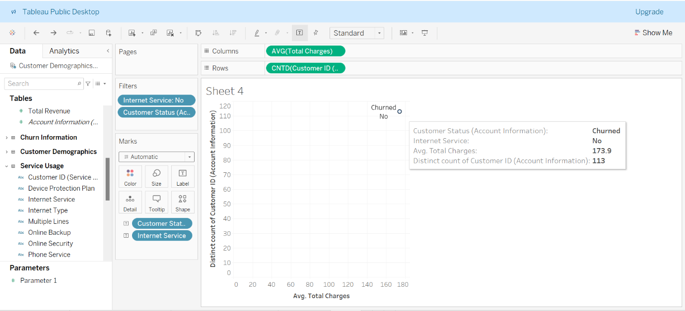

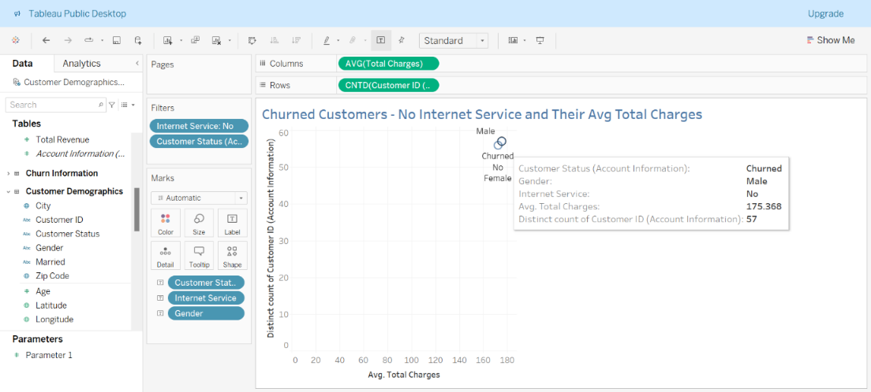

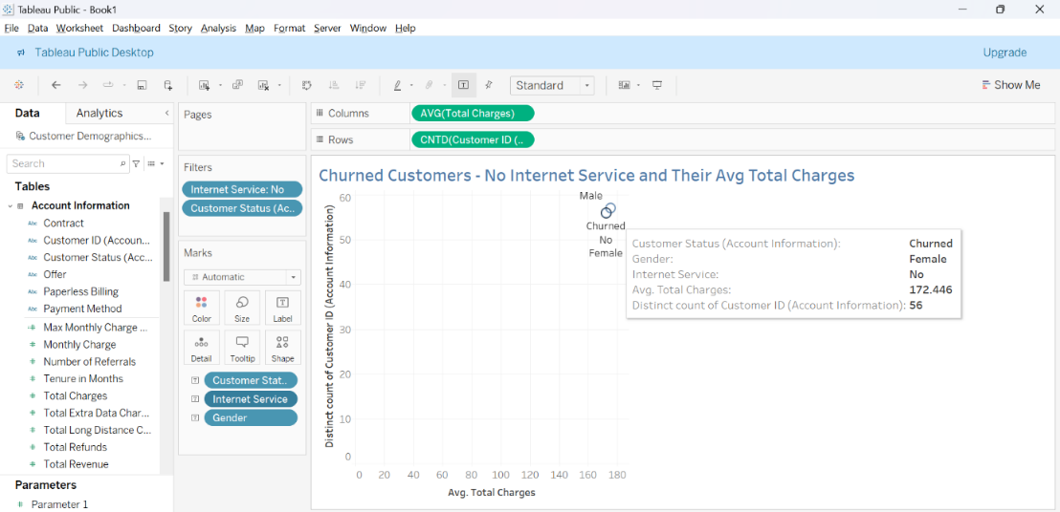

* From the visuals, among churned customers who do not have internet service and average. total charges.

**Power BI Visualizations:**

1. **Find the Average Age of Churned Customers**

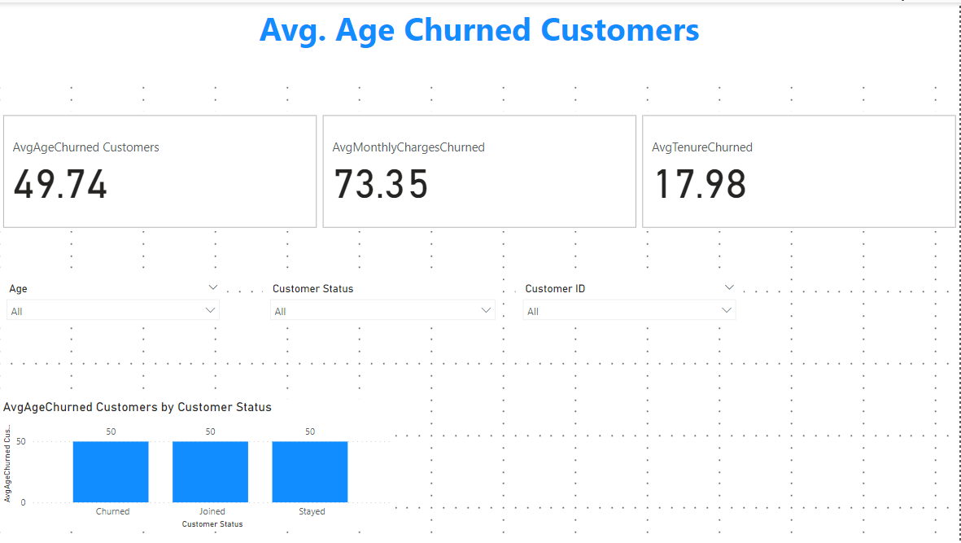

* Bar visual created, avg. age of churned customer measure clearly shows the average. age of churned customers.

1. **Analyze the Distribution of Monthly Charges Among Churned Customers**

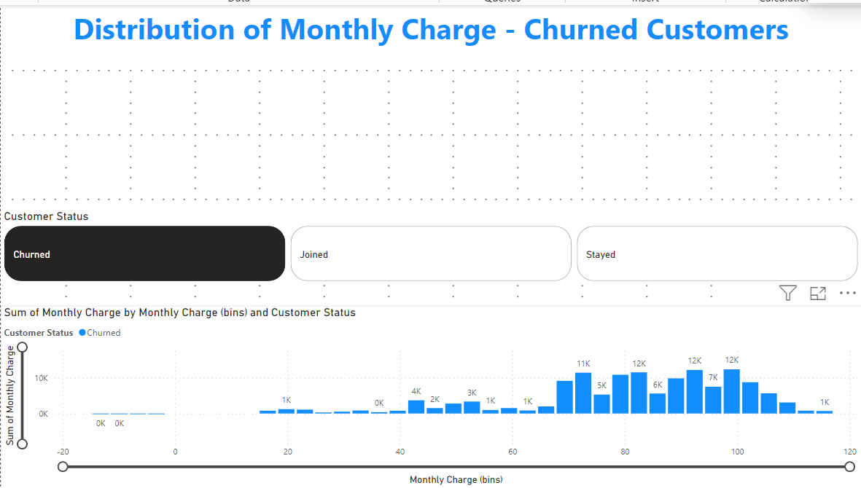

* For this visual, a monthly bin group was created, and customer status – was set as “churned’.

**13. Identify Customers with High Total Charges Who Have Churned**

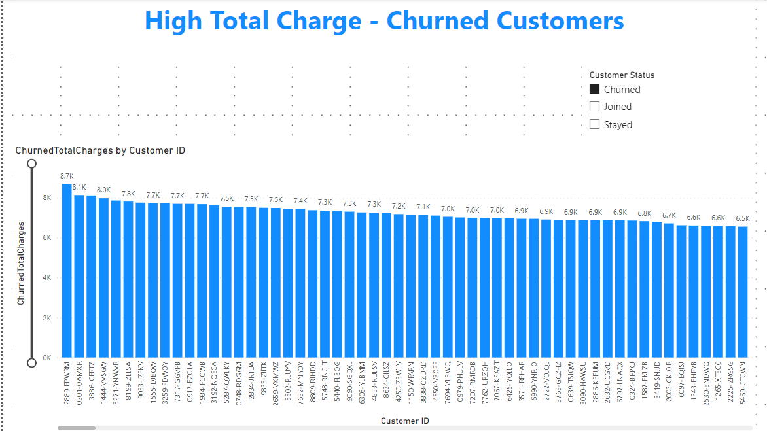

* From this, we can understand the High Total Charge among churned customers.
* Churned Total Charge measure used.
* Customer status “churned”

**Dashboards:**

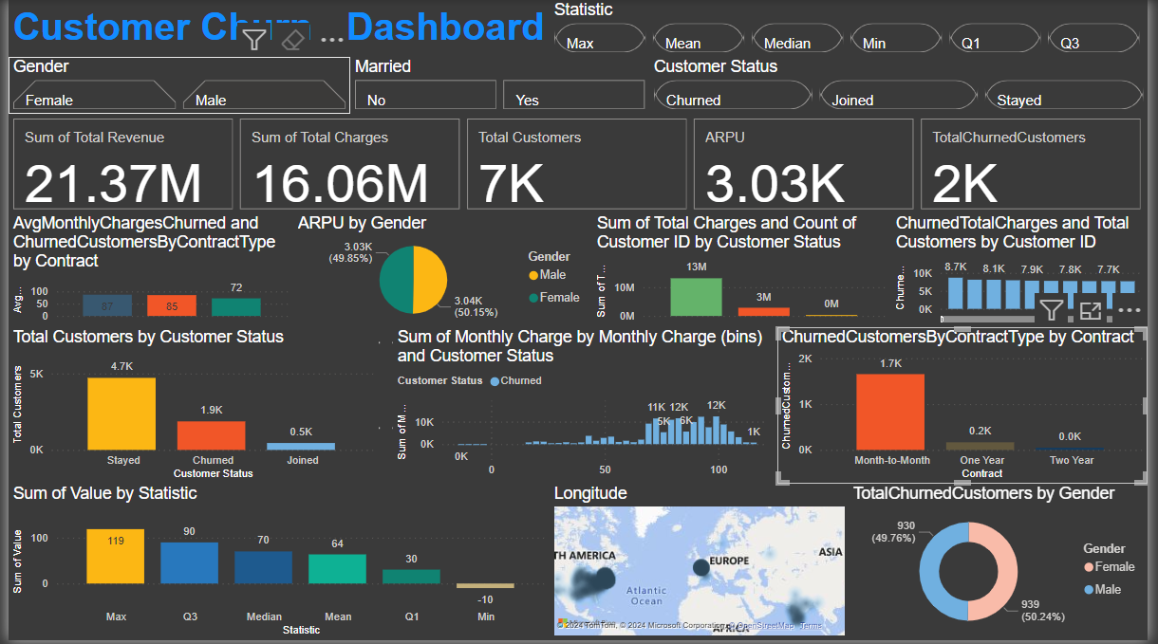

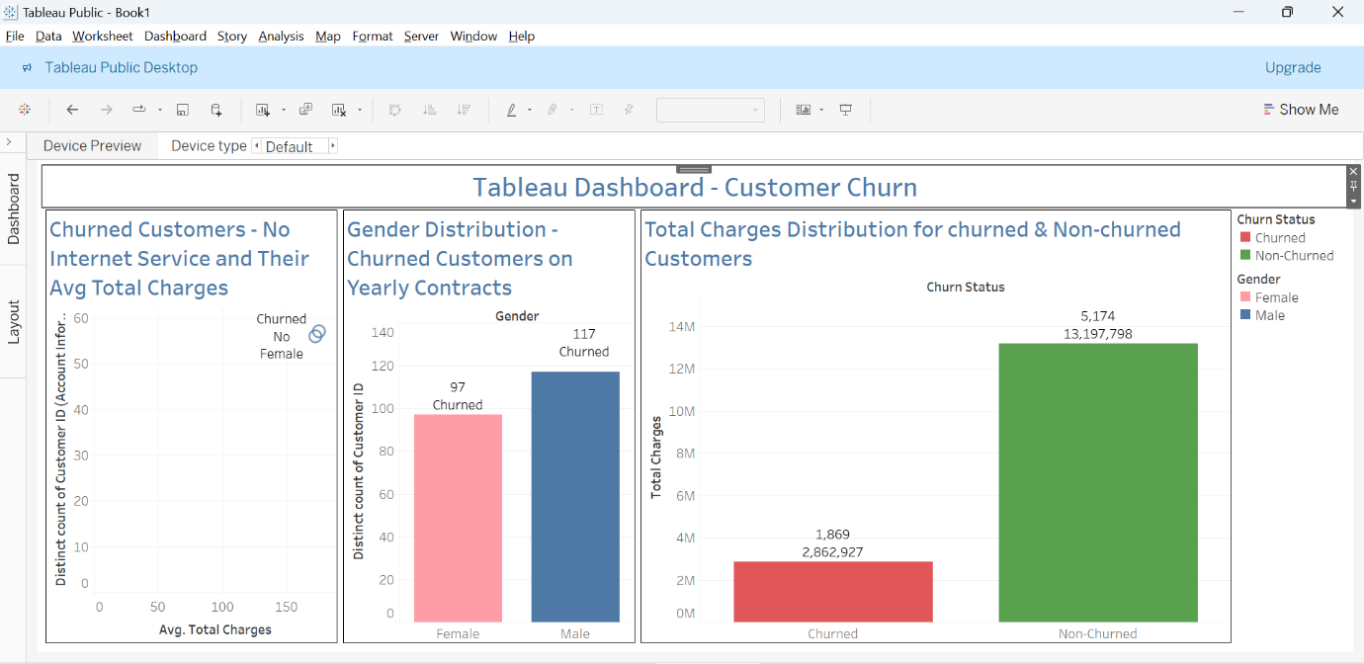

**Power BI Dashboard Explanation**

**Filters at the Top**:

* **Gender**: Allows filtering data by gender (Female, Male).
* **Married**: Allows filtering by marital status (Yes, No).
* **Customer Status**: Allows filtering by customer status (Churned, Joined, Stayed).

**Key Metrics**:

* **Sum of Total Revenue**: Displays the total revenue generated.
* **Sum of Total Charges**: Displays the total charges.
* **Total Customers**: Displays the total number of customers.
* **ARPU (Average Revenue Per User)**: Displays the ARPU value.
* **Total Churned Customers**: Displays the total number of customers who have churned.

**Charts and Graphs**:

* **Avg Monthly Charges Churned and Churned Customers by Contract Type**: A bar chart showing average monthly charges for churned customers categorized by contract type.
* **Total Customers by Customer Status**: A bar chart displaying the number of customers by their status (Stayed, Churned, Joined).
* **ARPU by Gender**: A pie chart showing ARPU values for Male and Female customers.
* **Sum of Total Charges and Count of Customer ID by Customer Status**: A bar chart representing the sum of total charges and count of customer IDs, categorized by customer status.
* **Sum of Monthly Charge by Monthly Charge (bins) and Customer Status**: A histogram showing the distribution of monthly charges for churned customers.
* **Churned Total Charges and Total Customers by Customer ID**: A bar chart showing total charges and the number of churned customers.
* **Churned Customers by Contract Type by Contract**: A bar chart showing the number of churned customers by contract type.
* **Total Churned Customers by Gender**: A pie chart representing the gender distribution of churned customers.

**Map**:

* **Total Churned Customers by Geography**: A map visual showing the geographical distribution of churned customers.

**Other Visuals**:

* **Sum of Value by Statistic**: A bar chart displaying the sum of values by various statistics like Max, Q3, Median, Mean, Q1, Min.

**Tableau Dashboard Explanation**

1. **Churned Customers - No Internet Service and Their Average Total Charges**:
   * This visualization shows the distribution of churned customers who do not use internet service and their average total charges.
2. **Gender Distribution - Churned Customers on Yearly Contracts**:
   * This bar chart shows the distribution of churned customers on yearly contracts by gender.
3. **Total Charges Distribution for Churned and Non-Churned Customers**:
   * This bar chart compares the total charges for churned and non-churned customers.

**General Insights from Both Dashboards**

* **Churn Analysis by Contract Type**:
  + In Power BI, the dashboard reveals that month-to-month contracts have the highest churn rate, which is visually represented in the "Churned Customers by Contract Type" bar chart.
* **Gender Distribution**:
  + Both dashboards provide insights into the gender distribution of churned customers. In Tableau, a bar chart specifically highlights churned customers on yearly contracts by gender.
* **Revenue and Charges**:
  + Both dashboards display metrics like total revenue, total charges, and ARPU. Power BI provides detailed breakdowns and distributions of these metrics.
* **Customer Status and Churn Rate**:
  + Both dashboards give an overview of customer status, highlighting the number of churned, stayed, and joined customers. Power BI goes further by breaking down these metrics by various dimensions like contract type and monthly charges.
* **Geographical Distribution**:
  + The Power BI dashboard includes a map visual showing the geographical distribution of churned customers, which helps in understanding regional churn patterns.

These dashboards collectively provide a comprehensive view of customer churn, enabling the identification of key factors contributing to churn, demographic insights, and financial impacts. They can be used to inform strategic decisions to improve customer retention.

**Phase-4: Recommendations Based on Business Use Cases**

**1. Customer Retention: Identify At-Risk Customers and Proactively Implement Retention Strategies**

**Objective:** Minimize customer churn by identifying and addressing the needs of at-risk customers.

**Recommendations:**

* **Utilize Predictive Analytics:** Use machine learning models to predict which customers are most likely to churn. Implement targeted retention strategies for these customers.
* **Personalized Communication:** Reach out to at-risk customers with personalized offers and communication. Use data from the dashboards to tailor messages based on customer behavior and preferences.
* **Loyalty Programs:** Implement or enhance loyalty programs to reward long-term customers and provide incentives for staying.
* **Customer Feedback:** Regularly collect and act on customer feedback to address issues before they lead to churn.

**2. Marketing Campaigns: Tailor Marketing Efforts Towards Customers Who Are More Likely to Churn**

**Objective:** Increase the effectiveness of marketing campaigns by focusing on customers who are at risk of leaving.

**Recommendations:**

* **Segmented Campaigns:** Use customer segmentation data to create targeted marketing campaigns. For instance, customers with high monthly charges but who are not using certain services can be targeted with campaigns promoting those services.
* **Special Offers:** Develop special offers and discounts specifically aimed at at-risk customers to encourage them to stay.
* **Engagement Strategies:** Implement engagement strategies that address the specific needs and pain points of at-risk customers.

**3. Service Improvement: Analyze Churn Patterns to Improve Service Offerings and Customer Support**

**Objective:** Enhance service quality and customer support to reduce churn rates.

**Recommendations:**

* **Service Usage Analysis:** Analyze the service usage patterns of churned customers to identify which services are underutilized or problematic. Improve these services based on customer feedback and usage data.
* **Support Enhancements:** Invest in improving customer support channels, including quicker response times, better training for support staff, and more comprehensive self-service options.
* **Quality Assurance:** Regularly monitor and improve service quality, ensuring that customers receive consistent and reliable service.

**4. Revenue Optimization: Reduce Churn Rates to Maintain a Steady Revenue Stream**

**Objective:** Ensure stable and growing revenue by minimizing customer churn.

**Recommendations:**

* **Churn Impact Analysis:** Regularly assess the financial impact of churn and prioritize efforts to retain high-value customers.
* **Revenue Forecasting:** Use historical churn data to forecast revenue and identify potential risks. Adjust business strategies accordingly.
* **Bundling Services:** Offer bundled services at a discounted rate to increase customer stickiness and reduce churn.

**5. Customer Segmentation: Segment Customers Based on Churn Probability to Offer Personalized Experiences**

**Objective:** Enhance customer experience by providing personalized services and offers.

**Recommendations:**

* **Behavioral Segmentation:** Use data from the dashboards to segment customers based on their behavior, such as service usage, support interactions, and purchase history.
* **Personalized Offers:** Develop personalized offers and recommendations for different customer segments. For instance, customers on monthly contracts might be offered discounts for switching to annual contracts.
* **Experience Enhancement:** Use segmentation data to enhance the overall customer experience, addressing specific needs and preferences of different customer groups.

**Conclusion**

By leveraging the insights from the dashboards and implementing these recommendations, the business can proactively address customer churn, tailor marketing efforts, improve service quality, optimize revenue, and provide personalized experiences to different customer segments. This holistic approach will help in achieving long-term customer retention and business growth.